Divine Liturgy of the Pre-Sanctified Gifts

May this humble edition of the Liturgy of the Pre-Sanctified Gifts enable the faithful of our Church to sing God’s praises and behold His ineffable love for us.

Melita Mudri-Zubacz  
Fourth Week of the Great Fast  
March 10, 2010 – Winnipeg

Third Edition. Ottawa. March 2012

During the holy Great Fast, when a priest is to celebrate the Presanctified Liturgy, he makes the customary proskomedia-preparation on Sunday

The priest and deacon reverence the Holy Table while the Royal Doors remain closed. The deacon then receives a blessing and goes to his usual place before the Royal Doors and intones the following:

*Deacon:* Master, give the blessing.

*Priest:* Blessed be the Kingdom of the Father, and of the Son, and of the Holy Spirit, now and for ever and ever.

*All:* Amen.

Come, let us bow in worship before our King and God.

Come, let us bow in worship before Christ, our King and God.

Come, let us bow in worship and fall down before the very Lord Jesus Christ, our King and God.

While the faithful chant the following psalm, the priest prays the Prayers of Light before the Holy Doors. If all three stases are taken, the priest then begins with the fourth prayer.

Psalm 103

Bless the Lord, O my soul!\* You are very great O Lord, my God!

Clothed in pomp and brilliance;\* arrayed with light as with a cloak.

Stretching out the sky as a tent-cloth,\* covering Your lofty halls with water.

You make the clouds Your conveyance.\* You surge on the wings of the wind.

You make spirits Your messengers,\* and flaming fires Your attendants.

You settle the earth on its firm foundation;\* it shall stand unmoved from age to age.

The abyss covers it like a garment;\* waters stand over the mountains.

At Your rebuke they will take flight;\* at the peal of Your thunder they will fear.

They hurdle the hills and run down the dales,\* to the place You have chosen for them.

You have set up a boundary not to be passed;\* they shall never return to cover the earth.

Down in the gullies You make springs to rise;\* water shall go down between the mountains.

They shall give drink to the beasts of the field;\* wild asses will seek them to quench their thirst.

The birds of the sky will abide by them;\* from among the rocks they will raise their song.

From Your lofty halls You refresh the mountains;\* the earth shall be fed with the fruit of Your works.

You make green pastures for the cattle\* and food-plants for the service of all,

so that bread may be brought forth from the earth,\* and wine that gladdens the heart of man.

So that oil may put a gleam upon his face;\* and that bread may strengthen the heart

of all.

The trees of the plain will be satisfied,\* the cedars of Lebanon that he planted.

The sparrows will build their nests in them;\* and the herons will call them their home.

To the deer belong high mountains,\* to rodents, the shelter of the rocks.

You have made the moon to mark the seasons;\* the sun knows the time of its setting.

You establish darkness, and it is night\* wherein the forest creatures prowl around.

Young lions roar or their prey,\* and call out to God for their meat.

As the sun rises, they will come together,\* and lay themselves down in their dens.

Man will go out to his labour\* and work until eventide.

How great are Your works, O Lord,\* in wisdom You have wrought them all.

The earth is filled with Your creatures.\* Even the wide and open sea itself,\* within it there are countless creeping things,\* living beings small and large.

Upon it there are ships a-sailing,\* and that great beast You made to have fun.

All of them look up to You,\* to give them their food in due time.

You provide and they gather up;\* You open Your hand and they are full.

You hide Your face and they cringe;\* You suspend their breath, and they die and return to their dust.

You send forth Your breath and they live;\* You renew the face of the earth.

May the Lord’s glory endure forever,\* may the Lord rejoice in His works.

He looks upon the earth and makes it quake;\* He touches the mountains and they smoke.

I will sing to the Lord as long as I live;\* I will praise my God as long as I last.

Would that my thoughts be pleasing to Him,\* and I will rejoice in the Lord.

May sinners vanish from the earth,\* and may the wicked be no more.

Bless the Lord,\* O my soul!

The sun knows the time of its setting.\* You establish darkness, and it is night.

How great are Your works, O Lord,\* in wisdom You have wrought them all.

Glory be to the Father, and to the Son, and to the Holy Spirit,\*

now and for ever and ever. Amen.

And then, three times with a bow each time:

Alleluia! Alleluia! Alleluia!\* Glory be to You, O God! (3)

The Great Litany

*Deacon:* In peace let us pray to the Lord.

*All:* Lord, have mercy.

*Deacon:* For the peace from on high and for the salvation of our souls, let us pray to the Lord.

*All:* Lord, have mercy.

*Deacon:* For peace throughout the world, for the well-being of God’s holy Churches and for the unity of all, let us pray to the Lord.

*All:* Lord, have mercy.

*Deacon:* For this holy church and for all who enter it with faith, reverence, and fear of God, let us pray to the Lord.

*All:* Lord, have mercy.

*Deacon:* For the most holy universal Pontiff, *N.*, Pope of Rome, our most blessed Patriarch, *N.*, our most reverend Metropolitan, *N.*, our God-loving Bishop, *N.*, the reverend priesthood, the diaconate in Christ, and all the clergy and the people, let us pray to the Lord.

*All:* Lord, have mercy.

*Deacon:* For our nation under God, for our government, and for all the military, let us pray to the Lord.

*All:* Lord, have mercy.

*Deacon:* For this city (or for this village, or for this holy monastery), for every city and country and for the faithful who live in them, let us pray to the Lord.

*All:* Lord, have mercy.

*Deacon:* For favourable weather, for an abundance of the fruits of the earth, and for peaceful times, let us pray to the Lord.

*All:* Lord, have mercy.

*Deacon:* For the seafarers and travellers, for the sick and the suffering, for those held captive, and for their salvation, let us pray to the Lord.

*All:* Lord, have mercy.

*Deacon:* That we may be delivered from all tribulation, wrath, and misfortune, let us pray to the Lord.

*All:* Lord, have mercy.

*Deacon:* Help and save, have mercy and protect us, O God, by Your grace.

*All:* Lord, have mercy.

*Deacon:* Remembering our most holy and immaculate, most blessed and glorious Lady, the Mother of God and ever-virgin Mary, together with all the saints, let us commend ourselves and one another and our whole life to Christ our God.

*All:* To You, O Lord.

*Priest:* For all glory, honour, and worship befit You, Father, Son and Holy Spirit, now and for ever and ever.

*All:* Amen.

Kathisma XVIII

*The First Stasis - Psalms 119-123*

*Psalm 119*

In my distress I cry to the Lord, that he may answer me: “Deliver me, O Lord, from lying lips, from a deceitful tongue.” What shall be given to you? And what more shall be done to you, you deceitful tongue? A warrior’s sharp arrows, with glowing coals of the broom tree! Woe is me, that I am an alien in Meshech, that I must live among the tents of Kedar. Too long have I had my dwelling among those who hate peace. I am for peace; but when I speak, they are for war.

*Psalm 120*

I lift up my eyes to the hills – from where will my help come? My help comes from the Lord, who made heaven and earth. He will not let your foot be moved; he who keeps you will not slumber. He who keeps Israel will neither slumber nor sleep. The Lord is your keeper; the Lord is your shade at your right hand. The sun shall not strike you by day, nor the moon by night. The Lord will keep you from all evil; he will keep your life. The Lord will keep your going out and your coming in from this time on and forevermore.

Psalm 121 (122)

I was glad when they said to me, “Let us go to the house of the Lord!” Our feet are standing within your gates, O Jerusalem. Jerusalem – built as a city that is bound firmly together. To it the tribes go up, the tribes of the Lord, as was decreed for Israel, to give thanks to the name of the Lord. For there the thrones for judgment were set up, the thrones of the house of David. Pray for the peace of Jerusalem: “May they prosper who love you. Peace be within your walls, and security within your towers.” For the sake of my relatives and friends I will say, “Peace be within you.” For the sake of the house of the Lord our God, I will seek your good.

*Psalm 122*

To you I lift up my eyes, O you who are enthroned in the heavens! As the eyes of servants look to the hand of their master, as the eyes of a maid to the hand of her mistress, so our eyes look to the Lord our God, until he has mercy upon us. Have mercy upon us, O Lord, have mercy upon us, for we have had more than enough of contempt. Our soul has had more than its fill of the scorn of those who are at ease, of the contempt of the proud.

*Psalm 123*

If it had not been the Lord who was on our side – let Israel now say – if it had not been the Lord who was on our side, when our enemies attacked us, then they would have swallowed us up alive, when their anger was kindled against us; then the flood would have swept us away, the torrent would have gone over us; then over us would have gone the raging waters. Blessed be the Lord, who has not given us as prey to their teeth. We have escaped like a bird from the snare of the fowlers; the snare is broken, and we have escaped. Our help is in the name of the Lord, who made heaven and earth.

Glory be to the Father, and to the Son, and to the Holy Spirit,\* now and for ever and ever. Amen.

And then three times, each with a bow:

Alleluia! Alleluia! Alleluia!\* Glory be to You, O God! *(3)*

Small Litany

*Deacon:* Again and again in peace let us pray to the Lord.

*All:* Lord, have mercy.

*Deacon:* Help and save, have mercy and protect us, O God, by Your grace.

*All:* Lord, have mercy.

*Deacon:* Remembering our most holy and immaculate, most blessed and glorious Lady, the Mother of God and ever-virgin Mary, together with all the saints, let us commend ourselves and one another and our whole life to Christ our God.

*All:* To You, O Lord.

*The First Prayer of Light*

*Priest:* O Lord, compassionate and loving, long-suffering and most merciful, hear our prayer and listen to the voice of our supplication. Make a favourable covenant with us, guide us along Your ways that we may live in Your truth, gladden our hearts that we may fear Your holy name; for You are great and You perform wondrous deeds. You are the only God and none other is like You, O Lord. You are great in mercy and able, in Your power, to assist, support, and save all those who place their hope in Your holy name;

*Priest:* For Yours is the majesty, and Yours is the Kingdom and the power and the glory, of the Father, and of the Son and of the Holy Spirit, now and for ever and ever.

*All:* Amen.

*The Second Stasis - Psalms 124-128*

*Psalm 124*

Those who trust in the Lord are like Mount Sion, which cannot be moved, but abides forever. As the mountains surround Jerusalem, so the Lord surrounds his people, from this time on and forevermore. For the sceptre of wickedness shall not rest on the land allotted to the righteous, so that the righteous might not stretch out their hands to do wrong. Do good, O Lord, to those who are good, and to those who are upright in their hearts. But those who turn aside to their own crooked ways the Lord will lead away with evildoers. Peace be upon Israel!

*Psalm 125*

When the Lord restored the fortunes of Sion, we were like those who dream. Then our mouth was filled with laughter, and our tongue with shouts of joy; then it was said among the nations, “The Lord has done great things for them.” The Lord has done great things for us, and we rejoiced. Restore our fortunes, O Lord, like the watercourses in the Negeb. May those who sow in tears reap with shouts of joy. Those who go out weeping, bearing the seed for sowing, shall come home with shouts of joy, carrying their sheaves.

*Psalm 126*

Unless the Lord builds the house, those who build it labour in vain. Unless the Lord guards the city, the guard keeps watch in vain. It is in vain that you rise up early and go late to rest, eating the bread of anxious toil; for he gives sleep to his beloved. Sons are indeed a heritage from the Lord, the fruit of the womb a reward. Like arrows in the hand of a warrior are the sons of one’s youth. Happy is the man who has his quiver full of them. He shall not be put to shame when he speaks with his enemies in the gate.

*Psalm 127*

Blessed is everyone who fears the Lord, who walks in his ways. You shall eat the fruit of the labour of your hands; you shall be happy, and it shall go well with you. Your wife will be like a fruitful vine within your house; your children will be like olive shoots around your table. Thus shall the man be blessed who fears the Lord. The Lord bless you from Sion. May you see your children’s children. Peace be upon Israel!

*Psalm 128*

“Often have they attacked me from my youth” – let Israel now say – “often have they attacked my from my youth, yet they have not prevailed against me. The plowers plowed on my back; they made their furrows long.” The Lord is righteous; he has cut the cords of the wicked. May all who hate Sion be put to shame and turned backward. Let them be like the grass on the housetops that withers before it grows up, with which reapers do not fill their hands or binders of sheaves their arms, while those who pass by do not say, “The blessing of the Lord be upon you! We bless you in the name of the Lord!”

Glory be to the Father, and to the Son, and to the Holy Spirit,\* now and for ever and ever. Amen.

And then three times, each with a bow:

Alleluia! Alleluia! Alleluia!\* Glory be to You, O God! *(3)*

Small Litany

*Deacon:* Again and again in peace let us pray to the Lord.

*All:* Lord, have mercy.

*Deacon:* Help and save, have mercy and protect us, O God, by Your grace.

*All:* Lord, have mercy.

*Deacon:* Remembering our most holy and immaculate, most blessed and glorious Lady, the Mother of God and ever-virgin Mary, together with all the saints, let us commend ourselves and one another and our whole life to Christ our God.

*All:* To You, O Lord.

*The Second Prayer of Light*

*Priest:* O Lord, in Your indignation do not rebuke us; in Your wrath do not chastise us; but deal with us according to Your loving-kindness. O Physician and Healer of our souls, guide us to the harbour of Your will; enlighten the eyes of our mind that we may know Your truth. Grant that the remainder of this day and all the days of our life may be peaceful and without sin, through the prayers of the holy Mother of God and through the prayers of all the Saints

*Priest:* For You are a good and loving God, and we give glory to You, Father, Son and Holy Spirit, now and for ever and ever.

*All:* Amen.

*The Third Stasis - Psalms 129-133*

*Psalm 129*

Out of the depths I cry to you, O Lord, Lord, hear my voice! Let your ears be attentive to the voice of my supplications! If you, O Lord, should mark iniquities, Lord, who could stand? But there is forgiveness with you, so that you may be revered. I wait for the Lord, my soul waits, and in his word I hope; my soul waits for the Lord more than those who watch for the morning, more than those who watch for the morning. O Israel, hope in the Lord! For with the Lord there is steadfast love, and with him is great power to redeem. It is he who will redeem Israel from all its iniquities.

*Psalm 130*

O Lord, my heart is not lifted up, my eyes are not raised too high; I do not occupy myself with things too great and too marvellous for me. But I have calmed and quieted my soul, like a weaned child with its mother; my soul within me is like a weaned child.

*Psalm 131*

O Lord, remember in David’s favour all the hardships he endured; how he swore to the Lord and vowed to the Mighty One of Jacob, “I will not enter my house or get into my bed; I will not give sleep to my eyes or slumber to my eyelids, until I find a place for the Lord, a dwelling place for the Mighty One of Jacob.” We heard of it in Ephrathah; we found it in the fields of Jaar. “Let us go to his dwelling place; let us worship at his footstool.” Rise up, O Lord, and go to your resting place, you and the ark of your might. Let your priests be clothed with righteousness, and let your faithful shout for joy. For your servant David’s sake do not turn away the face of your anointed one. The Lord swore to David a sure oath from which he will not turn back: “One of the sons of your body I will set on your throne. If your sons keep my covenant and my decrees that I shall tech them, their sons also, forevermore, shall sit on your throne.” For the Lord has chosen Sion; he has desired it for his habitation: “This is my resting place forever; here I will reside, for I have desired it.. I will abundantly bless its provisions; I will satisfy its poor with bread. Its priests I will clothe with salvation, and its faithful will shout for joy. There I will cause a horn to sprout up for David; I have prepared a lamp for my anointed one. His enemies I will clothe with disgrace, but on him, his crown will gleam.”

*Psalm 132*

How very good and pleasant it is when kindred live together in unity! It is like the precious oil on the head, running down upon the beard, on the beard of Aaron, running down over the collar of his robes. It is like the dew of Hermon, which falls on the mountains of Sion. For there the Lord ordained his blessing, life forevermore.

*Psalm 133*

Come, bless the Lord, all you servants of the Lord, who stand by night in the house of the Lord! Lift up your hands to the holy place, and bless the Lord. May the Lord, maker of heaven and earth, bless you from Sion.

Glory be to the Father, and to the Son, and to the Holy Spirit,\* now and for ever and ever. Amen.

And then three times, each with a bow:

Alleluia! Alleluia! Alleluia!\* Glory be to You, O God! *(3)*

Small Litany

*Deacon:* Again and again in peace let us pray to the Lord.

*All:* Lord, have mercy.

*Deacon:* Help and save, have mercy and protect us, O God, by Your grace.

*All:* Lord, have mercy.

*Deacon:* Remembering our most holy and immaculate, most blessed and glorious Lady, the Mother of God and ever-virgin Mary, together with all the saints, let us commend ourselves and one another and our whole life to Christ our God.

*All:* To You, O Lord.

*The Third Prayer of Light*

*Priest:* O Lord our God, be mindful of us sinners, Your unworthy servants, as we call upon Your holy name, and put us not to shame for having placed our hope in Your mercy. Graciously grant us, O Lord, all the means of salvation; make us worthy to love and fear You with all our heart and to accomplish Your will in all things.

*Priest:* For You are our God, the God who has mercy and who saves, and we give glory to You, Father, Son and Holy Spirit, now and for ever and ever.

*All:* Amen.

Lamp-Lighting Psalms

*Psalm 140*

O Lord, I have cried to You, hear me;\* Hear me, O Lord!\* O Lord, I have cried to You, hear me;\* receive the voice of my prayer when I call upon You.\* Hear me, O Lord!

Let my prayer rise like incense before You;\* and the lifting up of my hands as an evening sacrifice.\* Hear me, O Lord!

The lector, standing at the centre of the Church, chants the following:

Set a guard, O Lord, before my mouth\* and a portal around my lips.

Incline my heart away from evil dealings,\* from finding excuses for sinful deeds.

In company with those who work iniquity,\* let me not partake of what they choose.

May the just chasten me with justice and reprove me;\* may the oil of the wicked never touch my head.

Yet even then shall I pray for their welfare.\* Their rulers were swallowed near the rock.

My words will be heard, for they were sweet.\* As a lump of clay broken on the ground, so their bones were strewn near the grave.

To You, Lord, O Lord, my eyes are lifted up.\* In You have I hoped; let not my soul be lost.

Keep me from the snare that was set for me,\* and from the stumbling-blocks of the wicked.

The wicked shall fall into their own nets,\* while I remain alone until I can escape.

*Psalm 141*

With my voice I cried to the Lord;\* with all my voice I implored the Lord.

Before Him I pour out my supplications;\* before Him I declare my distress.

When my breath was escaping me,\* then you knew my paths;

On the road upon which I was walking,\* they set up snares for me.

I looked to my right and observed\* there was no one friendly to me;

Even flight was denied me;\* there was no one to take care of my life.

I cried out to You, O Lord, and said: You are my hope, my share in the land of the living.

Listen to my supplication,\* for I am laid very low.

Deliver me from my oppressors,\* for they have overwhelmed me.

The assigned stichera are now interspersed with the psalm:

*(for 10)* Lead my soul forth from prison,\* that I may give thanks to Your name.

*(for 9)* The just shall gather around me\* when You have been good to me.

*Psalm 129*

*(for 8)* Out of the depths I cry to You, O Lord;\* O Lord, hear my voice!

*(for 7)* Let Your ears be attentive\* to the voice of my prayer.

*(for 6)* If You mark iniquities, Lord, who can stand?\* But with You forgiveness is that You may be revered.

*(for 5)* I have waited for You as You have commanded; my soul patiently relies on Your promise,\* for it has trusted in the Lord.

*(for 4)* From the morning watch until night\* let Israel trust in the Lord.

*(for 3)* For with the Lord there is mercy, and with Him there is plentiful redemption;\* and He shall redeem Israel from all its iniquities.

*Psalm 116*

*(for 2)* Praise the Lord, all the nations;\* proclaim His glory, all you people.

*(for 1)* Strong is the love of the Lord for us;\* eternally will His truth endure.

Glory be to the Father, and to the Son, and to the Holy Spirit.

Now and for ever and ever. Amen.

Entrance

On Glory... the deacon opens the Royal Doors, takes the censer (and the Holy Gospel if there is to be a reading from it), and together with the priest process around the Holy Table and stand before the Royal Doors. Then, they pray as follows:

*Deacon:* Let us pray to the Lord.

*Priest:* Evening, morning and noon we praise You, we bless You, we thank You and we pray to You, Master of all, loving Lord. Direct our prayer like incense before You and do not turn our hearts aside to mere words or to evil thoughts, but save us from all those who want to ensnare our souls. Our eyes are turned to You, Lord, and upon You we have placed our hope. Do not cover us with shame, our God. All glory, honour and worship belong to You, the Father and the Son, and the Holy Spirit, now and for ever and ever. Amen.

*Deacon:* Amen. Master, bless the holy entrance!

*Priest:* Blessed is the entrance into Your holy places, always, now and for ever and ever. Amen.

Tranquil Light

*Deacon:* Wisdom! Stand aright!

All: Tranquil Light, of the holy glory of the immortal, heavenly, holy, blessed Father, O Jesus Christ: as we come upon the sunset, as we see the evening light, we sing to God, the Father, the Son, and the Holy Spirit. At all times You are worthy of being hymned by joyful voices; O Son of God, You are the giver of life. For this the whole world glorifies You.

Prokeimenon I

*Deacon:* Let us be attentive!

*Priest:* Peace be with all!

*Deacon:* Wisdom! Let us be attentive!

The lector announces and the people sing the first assigned Prokeimenon.

Reading I

*Deacon:* Wisdom!

*Lector:* A reading from the Book of …

*Deacon:* Let us be attentive!

The lector proclaims the first assigned reading.

Prokeimenon II

Once the reading has been completed, the lector immediately announces and the people sing the second prokeimenon.

*Deacon:* Command!

The priest, facing the Holy Table, makes the sign of the Cross with the candle and censer and exclaims:

*Priest:* Wisdom! Stand aright!

He then turns to the people and blesses them by making the sign of the Cross while singing:

*Priest:* The light of Christ illumines all!

The whole congregation makes three prostrations.

Reading II

Immediately after the three prostrations, the lector announces the second assigned reading.

*Lector:* A reading from the Book of …

*Deacon:* Let us be attentive!

After the reading the priest says:

*Priest:* Peace be with you.

*Deacon:* Wisdom!

Let My Prayer Rise…

Then, having stood in front of the Holy Table, the priest incenses and sings the following while the people kneel:

*Priest:* Let my prayer rise straight like incense before You; the lifting of my hands, the lifting of my hands, as evening sacrifice.

The people repeat as they stand and the clergy kneel.

*All:* Let my prayer rise straight like incense before You; the lifting of my hands, the lifting of my hands, as evening sacrifice.

*Priest:* O Lord, I have cried to You, hear me - receive the voice of my prayer when I call upon you.

*All:* Let my prayer rise straight like incense before You; the lifting of my hands, the lifting of my hands, as evening sacrifice.

*Priest:* Set a guard, O Lord, before my mouth and a portal around my lips.

*All:* Let my prayer rise straight like incense before You; the lifting of my hands, the lifting of my hands, as evening sacrifice.

*Priest:* Incline my heart from evil dealings from finding excuses for sinful deeds.

*All:* Let my prayer rise straight like incense before You; the lifting of my hands, the lifting of my hands, as evening sacrifice.

*Priest:* Let my prayer rise straight like incense before You;

*All:* the lifting of my hands, the lifting of my hands, as evening sacrifice.

All now make three prostrations while praying the prayer of St. Ephrem:

*Prayer of St. Ephrem*

O Lord and Master of my life, keep from me the spirit of indifference and discouragement, lust of power, and idle chatter. *Prostration*

Instead, grant to me, Your servant, the spirit of wholeness of being, humble-mindedness, patience, and love. *Prostration*

O Lord and King, grant me the grace to be aware of my sins and not to judge my brothers and sisters, for You are blessed, now and for ever and ever. Amen. *Prostration*

❖ ❖ ❖ ❖ ❖

On Feast-Days with Prescribed Readings

*Deacon:* Let us be attentive!

*Priest:* Peace be with all!

*Deacon:* Wisdom! Let us be attentive!

The lector announces and the people sing the assigned Prokeimenon.

*Deacon:* Wisdom!

*Lector:* A reading from the epistle …

*Deacon:* Let us be attentive!

The lector proclaims the assigned reading. After the reading the priest says:

*Priest:* Peace be with you.

*Deacon:* Wisdom! Let us be attentive!

As the deacon incenses as usual before the Gospel, the people sing Alleluia with the assigned verses sung by the lector, and the priest prays the following:

*Priest:* Make the pure light of Your Divine knowledge shine in our hearts, O loving Master. Open the eyes of our minds that we may understand the message of Your gospel. Instil in us the fear of Your blessed commandments that we may subdue all carnal desires and follow a spiritual way of life, thinking and doing all that pleases You. For You, O Christ our God, are the enlightenment of our souls and bodies, and we give glory to You, together with Your eternal Father and Your most holy, good, and life-giving Spirit, now and for ever and ever. Amen.

*Deacon:* Master, bless the reader of the Gospel of the holy apostle and evangelist *N*.

*Priest:* May God, through the intercession of the holy, glorious, all-praiseworthy apostle and evangelist name, grant that you proclaim the Good News with great power for the fulfilment of the Gospel of His beloved Son, our Lord Jesus Christ.

*Deacon:* Amen.

*Deacon:* Wisdom! Stand aright! Let us listen to the holy Gospel.

*Priest:* Peace be with all.

*All:* And with your spirit.

*Deacon:* A reading from the holy Gospel according to *N*.

*All:* Glory be to You, O Lord, glory be to You.

*Priest:* Let us be attentive!

The deacon proclaims the Gospel

*All:* Glory be to You, O Lord, glory be to You.

*Priest:* Peace be with you, proclaimer of the Good News.

❖ ❖ ❖ ❖ ❖

Litany of Supplication

*Deacon:* Let us all say with our whole soul and our whole mind, let us say:

*All:* Lord, have mercy.

*Deacon:* Almighty Lord, God of our Fathers, we pray You, hear us and have mercy.

*All:* Lord, have mercy.

*Deacon:* Have mercy on us, O God, in the greatness of Your compassion, we pray You, hear us and have mercy.

*All:* Lord, have mercy. *(3)*

*Deacon:* We also pray for the most holy universal Pontiff, *N.*, Pope of Rome; our most blessed Patriarch, *N.*, our most reverend Metropolitan, *N.*, our God-loving Bishop, *N.*, for those who serve and have served in this holy church, for our spiritual fathers, and for all our brethren in Christ.

*All:* Lord, have mercy. *(3)*

*Deacon:* We also pray for our nation under God, for our government, and for all the military.

*All:* Lord, have mercy. *(3)*

Special petitions may be inserted at this point in the litany.

*Deacon:* We also pray for the people here present who await Your great and bountiful mercies, for those who have been kind to us, and for all orthodox Christians.

*All:* Lord, have mercy. *(3)*

*Priest:* Lord our God, accept this fervent supplication from Your servants and in Your compassion have pity on us. Send down Your mercy upon us and upon all Your people who await Your rich mercy.

*Priest:* For You are a merciful and loving God, and we give glory to You, Father, Son and Holy Spirit, now and for ever and ever.

*All:* Amen.

Litany for the Catechumens

*Deacon:* Catechumens, pray to the Lord.

*All:* Lord, have mercy.

*Deacon:* Faithful, let us pray for the catechumens that the Lord may have mercy on them.

*All:* Lord, have mercy.

*Deacon:* That He may teach them by the word of truth.

*All:* Lord, have mercy.

*Deacon:* That He may reveal to them the Gospel of justice.

*All:* Lord, have mercy.

*Deacon:* That He may make them one with His holy, catholic, and apostolic Church.

*All:* Lord, have mercy.

*Deacon:* Help and save, have mercy and protect them, O God, by Your grace.

*All:* Lord, have mercy.

*Deacon:* Catechumens, bow your heads to the Lord.

*All:* To You, O Lord.

*Prayer for the Catechumens*

*Priest:* God, our God, Creator and Maker of all, You Who want all to be saved and to come to the knowledge of truth, look upon Your servants, the catechumens, and rescue them from the ancient deceit and the wiles of the adversary. Call them to eternal life, enlighten their souls and bodies, and number them in Your spiritual flock over whom Your holy name is invoked.

*Priest:* That together with us they too may glorify Your most holy and magnificent name, of the Father, and of the Son, and of the Holy Spirit, now and forever and ever.

*All:* Amen.

The priest unfolds the iliton.

From the beginning until Wednesday of the fourth week of the Great Fast, the Deacon: All

Deacon: Again and again in peace let the faithful pray to the Lord.

All: Lord, have mercy.

Great and praiseworthy God, who by the life-giving death of Your Christ transferred us from corruption to incorruption, free all our senses from death-dealing desires by placing our inner reason as a good governor over them. May our eye refrain from every evil glance. May our ear be inaccessible to idle words and our tongue be cleansed of unbecoming speech. Purify our lips that praise You, Lord. Keep our hands from evil deeds, and may they do only what pleases You. Strengthen all our members and our understanding by Your grace.

Master, holy and most good, rich in mercy, we entreat You to be merciful to us sinners. Make us worthy to welcome Your only-begotten Son, our God, the king of glory, for behold, at this time His most pure Body and life-giving Blood are coming escorted invisibly by a multitude of the heavenly host and are about to be placed upon this mystical altar. Let us receive Them without condemnation, and with the eye of our understanding enlightened by Them, let us become children of light and day.

Deacon: Wisdom!

Priest: Through the gift of Your Christ, with whom You are blessed, together with Your all-holy, good and life-giving Spirit, now and for ever and ever.

All: Amen.

“NOW THE POWERS”

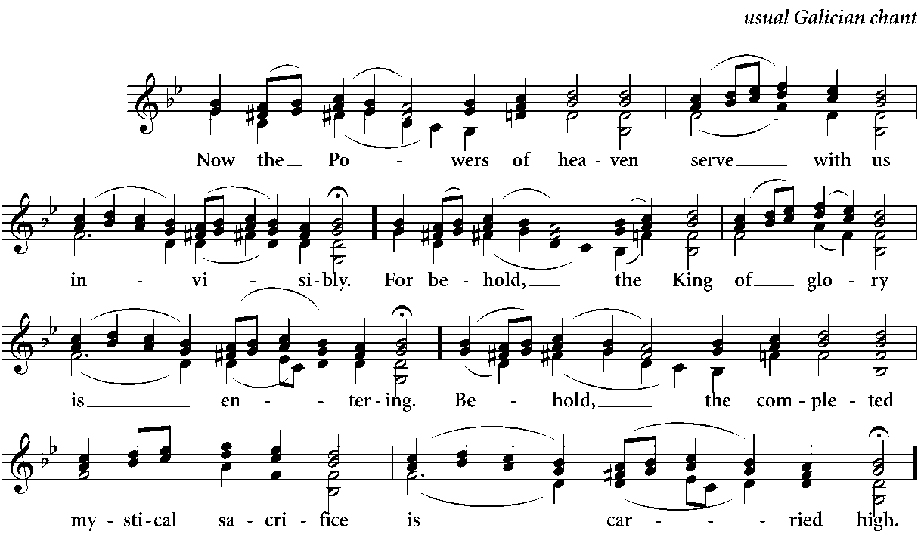

All:

The deacon incenses the holy table with three swings only from the front side, and then the table of prothesis. Then together with the priest they say: Now the Powers of heaven serve with us invisibly. For behold, the King of glory is entering. Behold, the completed mystical sacrifice is carried high! Let us approach with faith and love so that we may partake of eternal life. Alleluia, alleluia, alleluia (thrice). Then they make the Great Entrance with the Pre-Sanctified Gifts in silence.

During the Entrance all the people prostrate in reverent adoration. After the Entrance they rise and sing the following and then make three prostrations while praying the prayer of St. Ephrem:

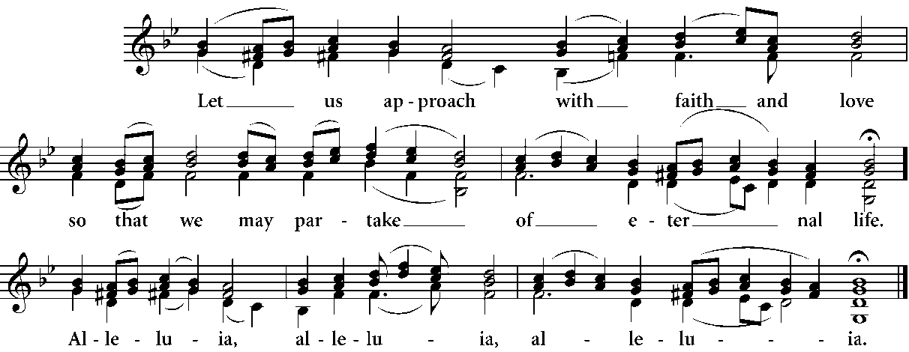

All:

O Lord and Master of my life, keep from me the spirit of indifference and discouragement, lust of power, and idle chatter. (Prostration)

Instead, grant to me, Your servant, the spirit of wholeness of being, humble-mindedness, patience, and love. (Prostration)

O Lord and King, grant me the grace to be aware of my sins and not to judge my brothers and sisters, for You are blessed, now and for ever and ever. Amen. (Prostration)

LITANY OF SUPPLICATION

Deacon: Let us complete our evening prayer to the Lord.

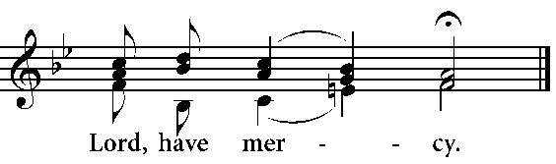

All:

Deacon: For the precious Gifts offered and pre-sanctified, let us pray to the Lord.

All: Lord, have mercy.

Deacon: That our God in His love for mankind may receive them on His holy, heavenly and mystical altar unto an aroma of spiritual fragrance and may send down upon us in return the divine grace and the gift of the Holy Spirit, let us pray to the Lord.

All: Lord, have mercy.

Deacon: That we may be delivered from all tribulation, wrath, and misfortune, let us pray to the Lord.

All: Lord, have mercy.

God of ineffable and invisible mysteries, in whom are hidden treasures of wisdom and knowledge, You have revealed the mysteries of this liturgy to us. In Your great love You appointed us, sinners though we are, to offer gifts and sacrifices for our sins and the sinful ignorance of the people. Invisible king, You perform deeds without number, great and inscrutable, glorious and extraordinary. Look with favour upon us, Your unworthy servants, standing at this You holy altar as at the throne of Your cherubim upon which Your only-begotten Son, our God, rests in the awesome Mysteries present here. You freed us and Your faithful people from all impurity. Sanctify all our lives and bodies with Your sanctification which cannot be taken away, so that with clean conscience, unashamed face and enlightened heart we may receive these divine Gifts and be given life by Them. And may we be united to Your Christ Himself, our God, who said: “Who eats my flesh and drinks my blood abides in me and I in him.” With Your Word dwelling in us and sojourning with us, Lord, let us become a temple of Your all-holy, adorable Spirit, freed from every wile of the devil worked by deed, word or thought. Together with all Your saints who have pleased You through the ages, may we obtain the good things promised us.

Deacon: Help and save, have mercy and protect us, O God, by Your grace.

All: Lord, have mercy.

Deacon: That this whole evening may be perfect, holy, peaceful, and sinless, let us ask the Lord.

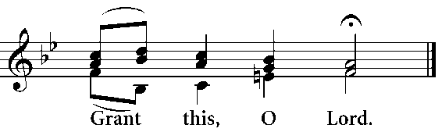

All:

Deacon: For an angel of peace, a faithful guide, a guardian of our souls and bodies, let us ask the Lord.

All: Grant this, O Lord.

Deacon: For the forgiveness and remission of our sins and offences, let us ask the Lord.

All: Grant this, O Lord.

Deacon: For all that is good and beneficial for our souls and for peace for the world, let us ask the Lord.

All: Grant this, O Lord.

Deacon: That we may spend the rest of our lives in peace and repentance, let us ask the Lord.

All: Grant this, O Lord.

Deacon: For a Christian end to our lives, one that is painless, unashamed, and peaceful; and for a good defence at the awesome tribunal of Christ, let us ask.

All: Grant this, O Lord.

Deacon: Having asked for unity of the faith and for the fellowship of the Holy Spirit, let us commend ourselves and one another and our whole life to Christ our God.

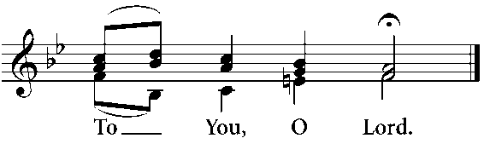

All:

Priest: Make us worthy, O Master, with confidence and without condemnation to dare call You, the heavenly God, Father, and say:

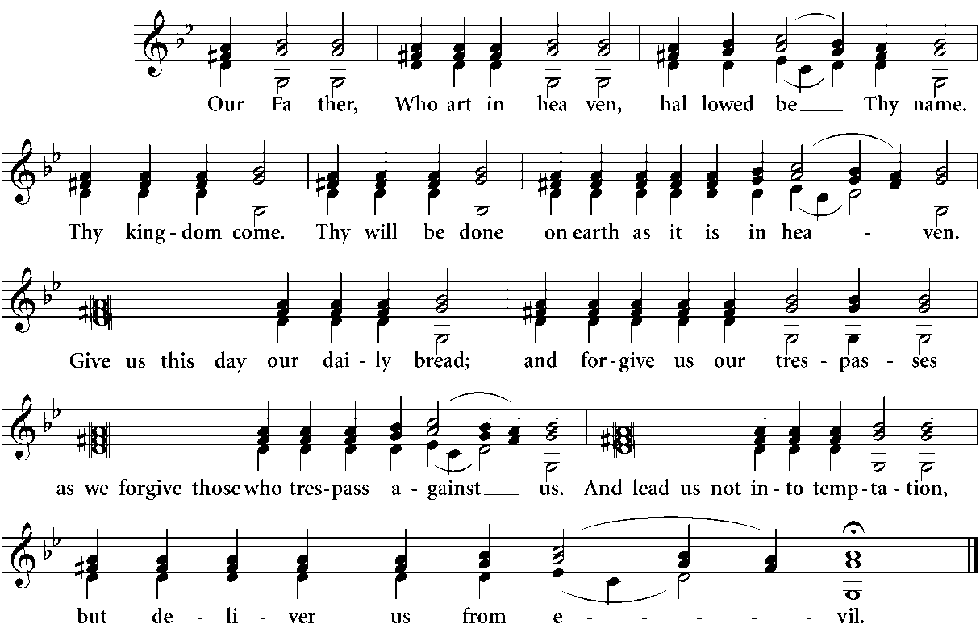

All:

Priest: For the kingdom, the power and the glory are Yours, Father, Son, and Holy Spirit, now and for ever and ever.

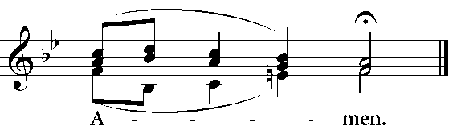

All:

Priest: Peace be with all.

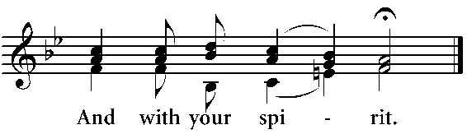

All:

Deacon: Bow your heads to the Lord.



All:

God, You who alone are good and merciful, who dwell on high and look with favour upon the humble, look with merciful eye upon all Your people and protect them. Make us all worthy of partaking of these Your life-giving Mysteries without condemnation, for we have bowed our heads to You hoping for great mercy from You.

Priest: Through the grace, mercies and loving-kindness of Your only-begotten Son with whom You are blessed together with Your most holy, good and life-giving Spirit, now and for ever and ever.

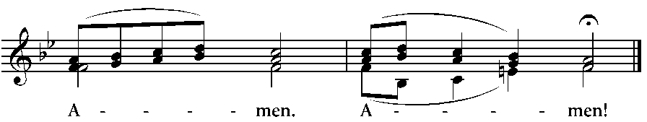

All:

Lord Jesus Christ our God, hear us from Your holy dwelling place, from the throne of Your glorious kingdom and come to sanctify us, You who are seated on high with the Father, yet are invisibly present here with us. With Your mighty hand, may it please You to give us Your pure Body and precious Blood, and through us to all Your people.

The priest and the deacon bow three times saying: God, be merciful to me, a sinner.

Deacon: Let us be attentive!

Priest: Pre-Sanctified Holy Things for the Holy!

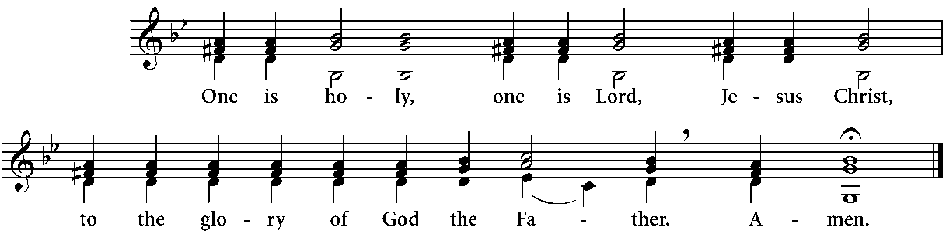

All:

Communion Verse:

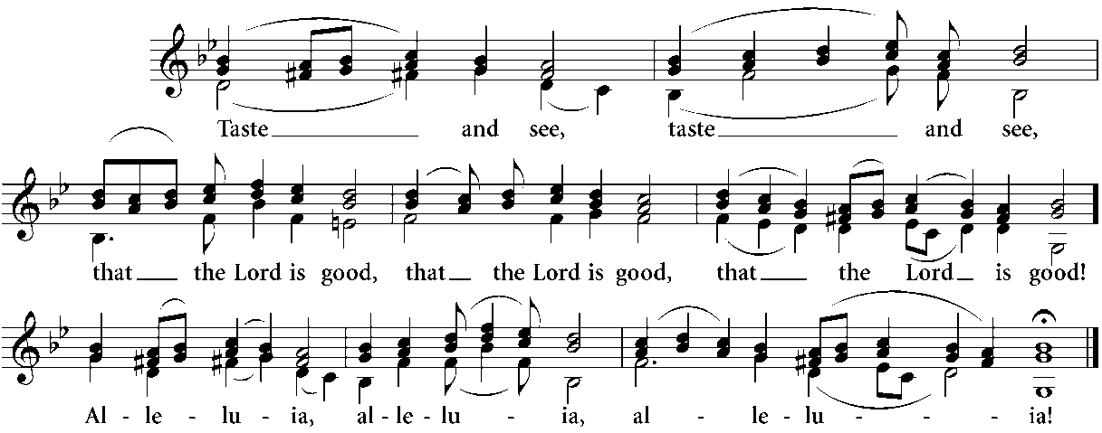

All:

In the case that the Epistle and the Gospel of a feast-day have been read earlier, then the communion verse of the feast-day is taken also.

PRAYER IN PREPARATION FOR THE COMMUNION

I believe, O Lord, and confess that You are truly Christ, the Son of the living God, who came into the world to save sinners, of whom I am first.

Accept me this day, O Son of God, as a partaker of Your Mystical Supper. I will not tell the mystery to Your enemies, nor will I give You a kiss as did Judas, but like the thief, I confess to You:

Remember me, O Lord, when You come into Your kingdom.

Remember me, O Master, when You come into Your kingdom.

Remember me, O Holy One, when You come into Your kingdom.

May the partaking of Your Holy Mysteries, O Lord, be unto me not for judgement or condemnation but for the healing of soul and body.

God, be merciful to me, a sinner.

God, cleanse me of my sins and have mercy on me.

I have sinned without number, forgive me, O Lord.

Deacon: Master, break the holy Bread.

Priest: Broken and distributed is the Lamb of God broken and not divided, always eaten and never consumed but sanctifying those who partake.

Priest: Deacon, approach.

Deacon: Behold, I approach our immortal King and God. Master, give me the precious and holy Body of our Lord and God and Saviour, Jesus Christ.

Priest: The precious and holy and most pure Body of our Lord and God and Saviour, Jesus Christ, is given to the reverend deacon name, for the forgiveness of his sins and for life everlasting.

Deacon: I believe, O Lord, and confess...

Priest: The precious and most holy Body of our Lord and God and Saviour, Jesus Christ, is given to me name, a priest, for the forgiveness of my sins and for life everlasting. Amen. I believe, O Lord, and confess...

Deacon: Approach!

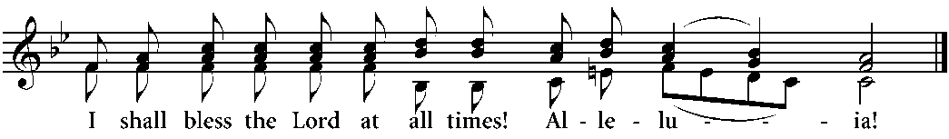

All:

Those who intend to receive Holy Communion come forward reverently and devoutly. In distributing Communion, the priest says:

The servant of God name, partakes of the precious, most holy and most pure Body and Blood of our Lord and God and Saviour, Jesus Christ, for the forgiveness of his/her sins and life everlasting. Amen.

During the distribution of Holy Communion the faithful sing Lenten songs, or the following:

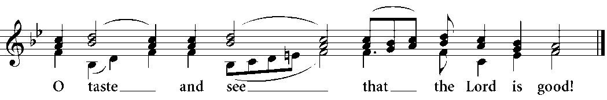

Refrain:

Psalm 33

I will bless the Lord at all times;\*

His praise shall be constantly in my mouth.

My soul shall glory in the Lord;\*

let the meek hear and rejoice.

Magnify the Lord with me,\*

and let us exalt His name together.

I sought the Lord and He heard me,\*

and delivered me from all my fears.

Approach the Lord and be enlightened,\*

and your face shall never be shamed.

The poor cried out and the Lord heard them\*

and delivered them from all their afflictions.

The angel of the Lord will set up camp\*

around those who fear the Lord and save them.

Taste and see how good the Lord is;\*

blessed is the one who hopes in Him.

Fear the Lord, all you His saints,\*

for there is no privation for those who fear Him.

The rich have become poor and hungry\*

but those who seek the Lord shall not want any good.

Once the priest has incensed the Holy Gifts, he takes the chalice and diskos and turns to the people saying:

Priest: Blessed is God who enlightens and sanctifies us, always, now and for ever and ever.

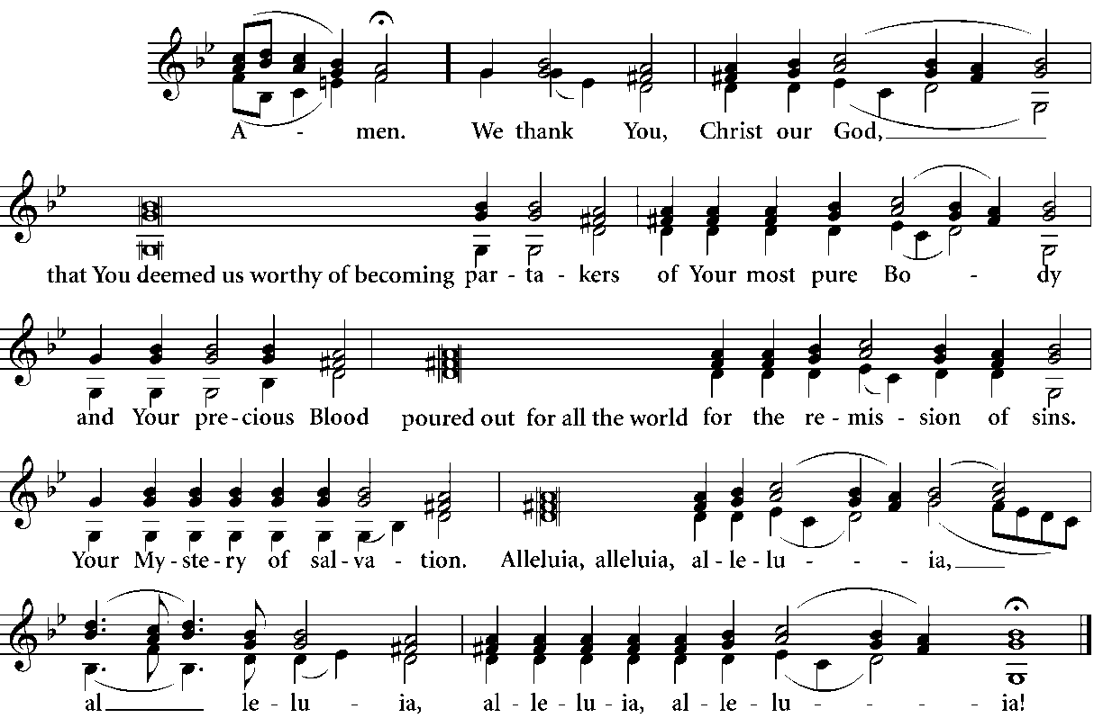

All:

LITANY OF THANKSGIVING

Deacon: Stand aright! Having received the divine, holy, immaculate, immortal, heavenly, and life-giving, awesome Mysteries of Christ, let us rightly give thanks to the Lord.



All:

Deacon: Help and save, have mercy and protect us, O God, by Your grace.

All: Lord, have mercy.

Deacon: Having asked that this evening may be perfect, holy, peaceful and sinless, let us commend ourselves and one another, and our whole life to Christ our God.



All:

Saviour and God of all, we thank You for all the good things You have given us and for the communion of the sacred body and blood of Your Christ. We beseech You, loving Master, keep us under the protection of Your wing and grant that until our last breath we may worthily partake of Your holy Gifts for enlightenment of our souls and bodies, for inheritance of the kingdom of heaven.

Priest: For You are our sanctification and we give glory to You, Father, Son and Holy Spirit, now and for ever and ever.



All:

Priest: Let us go forth in peace.

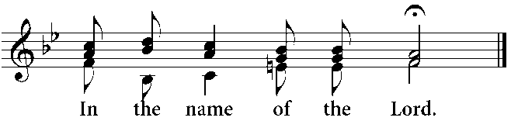

All:

Deacon: Let us pray to the Lord.



All:

Prayer Behind the Ambo

Almighty Lord, You made the whole world in wisdom. By Your ineffable foreknowledge and abounding goodness You brought us to these holy days for the purification of our souls and bodies, for the control of our passions and for the hope of resurrection. During the forty day period You gave the tablets in divinely inscribed letters to Your servant Moses. Grant also, good Lord, that we may fight the good fight, complete the course of fasting, keep the Faith intact, crush the heads of unseen enemies, be victorious over sin and so, without condemnation, to be ready for the worship of Your holy Resurrection. For blessed and glorified is Your most worthy and magnificent Name, Father, Son and Holy Spirit, now and for ever and ever.

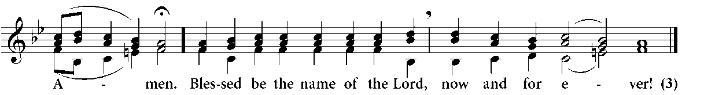

All:

Lord our God, You who brought us to these holy days and made us sharers of Your awesome Mysteries, join us to Your spiritual flock and make us inheritors of Your kingdom, now and for ever and ever. Amen.

It is not necessary to repeat Psalm 33 at this point, since it has been prayed already during the distribution of Holy Communion.

DISMISSAL

Here we resume singing the usual melodies for the responses.

Priest: The blessing of the Lord be upon you with His grace and love for mankind, always, now and for ever and ever.

All: Amen.

Priest: Glory be to You, O Christ our God, our hope, glory be to You.

All: Glory be to the Father, and to the Son, and to the Holy Spirit,\* now and for ever and ever. Amen.\* Lord, have mercy (3).\* Give the blessing.

Priest: Christ our true God, through the prayers of His immaculate Mother; of Saint name (patron of the temple) and Saint name (whose memory we celebrate), and all the saints, will have mercy and save us, for He is good and loves mankind.

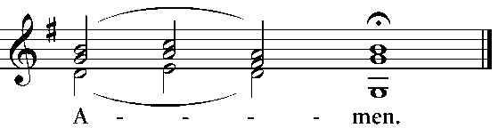

All:

Upon the completion of the liturgy, the following may be sung:

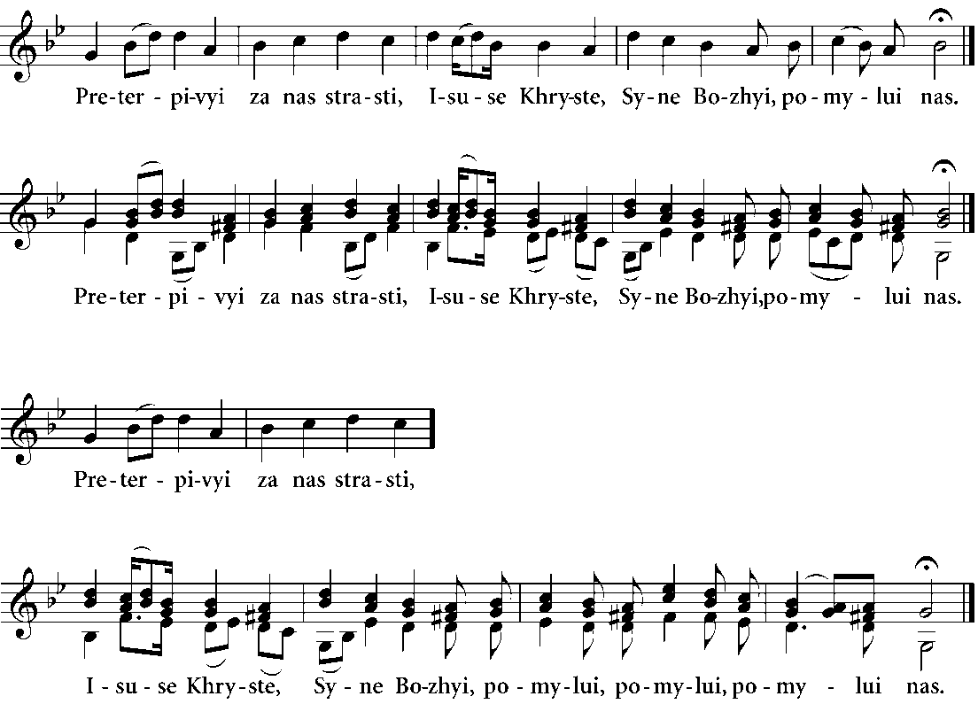

Priest:

All:

Priest:

All:



THE END OF THE DIVINE LITURGY OF THE PRE-SANCTIFIED GIFTS

GLORY TO GOD!

APPENDIX

PRAYERS OF LIGHT

The First Prayer of Light

O Lord, compassionate and loving, long-suffering and most merciful, hear our prayer and listen to the voice of our supplication. Make a favourable covenant with us, guide us along Your ways that we may live in Your truth, gladden our hearts that we may fear Your holy name; for You are great and You perform wondrous deeds. You are the only God and none other is like You, O Lord. You are great in mercy and able, in Your power, to assist, support, and save all those who place their hope in Your holy name; and to You, Father, Son, and Holy Spirit, is due all glory, honour, and adoration, now and for ever and ever. Amen.

The Second Prayer of Light

O Lord, in Your indignation do not rebuke us; in Your wrath do not chastise us; but deal with us according to Your loving-kindness. O Physician and Healer of our souls, guide us to the harbour of Your will; enlighten the eyes of our mind that we may know Your truth. Grant that the remainder of this day and all the days of our life may be peaceful and without sin, through the prayers of the holy Mother of God and through the prayers of all the Saints; for Yours is the might, and Yours is the kingdom and the power and the glory, Father, Son, and Holy Spirit, now and for ever and ever. Amen.

The Third Prayer of Light

O Lord our God, be mindful of us sinners, Your unworthy servants, as we call upon Your holy name, and put us not to shame for having placed our hope in Your mercy. Graciously grant us, O Lord, all the means of salvation; make us worthy to love and fear You with all our heart and to accomplish Your will in all things. For You are a gracious Lord and You love mankind; and we give glory to You, Father, Son, and Holy Spirit, now and for ever and ever. Amen.

The Fourth Prayer of Light

O Lord, You are praised by the holy Powers in hymns which are never silent, and in doxologies which never cease. Fill our mouths with Your praise that we may exalt Your holy name. Through the prayers of the holy Mother of God and the intercession of all Your Saints, give us a part and an inheritance with those who fear You in truth and who keep Your commandments. For to You, Father, Son, and Holy Spirit, is due all glory, honour, and adoration, now and for ever and ever. Amen.

The Fifth Prayer of Light

Blessed are You, O Lord, Almighty God. You know the mind of each person; You know what each needs even before they ask or are aware of it. Now, O King who loves mankind and who is gracious in everything, in Your great mercy allow us to call upon Your holy name with an unashamed conscience. And lead us not into temptation, but deliver us from the Evil One; for to You, Father, Son, and Holy Spirit, is due all glory, honour, and adoration, now and for ever and ever. Amen.

The Sixth Prayer of Light

O Lord, O Lord, You hold all things together in Your spotless hands; You are long-suffering toward us all; You grieve at our wickedness. Remember Your compassion and mercy, and look down upon us in Your goodness. Grant that for the rest of this day we may escape from the manifold deceits of the Evil One; and keep our life free from every assault of the enemy, through the grace of Your all-holy Spirit. Grant this through the mercies and love for mankind of Your only-begotten Son with whom You are blessed, together with Your all-holy, gracious, and life-giving Spirit, now and for ever and ever. Amen.

The Seventh Prayer of Light

O great and wonderful God, You govern all things with Your indescribable goodness and rich providence. You have provided us with the goodness of this world and have assured us, through Your kindness, of attaining the promised kingdom. O Lord, through all the blessings already received this day, You have kept us away from evil; grant that we spend its remaining hours without blame before Your holy glory, and that we may sing Your praise, O You, the only Gracious One who loves mankind. For You are our God, and we send up glory to You, Father, Son, and Holy Spirit, now and for ever and ever. Amen.

The Eighth Prayer of Light

O great and most high God, You alone are immortal and You dwell in a light which in unapproachable. You created all things in Your wisdom, dividing light from darkness, establishing the sun to govern the day and the moon and stars to rule the night. You have deemed us, poor sinners, worthy to reach this hour, to come into Your presence with our thanks, and to offer You our evening praise. O Lord who loves mankind, let our prayers ascend to You as incense, and accept them as a sweet fragrance. Grant that this evening and the coming night may be spent in peace; clothe us with the armour of light; save us from the fears of the night and from things that lurk in darkness. Grant that the sleep You have given to refresh us from our fatigue may be free from every evil. Yes, O Lord and Giver of all good things, may we remember Your name throughout the night; and enlightened by the practice of Your commandments, may we rise in gladness of soul to praise Your goodness, offering prayers and supplications for our sins and those of Your people. Look down upon us with mercy, through the intercession of the Mother of God; for You are a gracious Lord who loves mankind, and we glorify You, Father, Son, and Holy Spirit, now and for ever and ever. Amen.

DURING THE PASSION WEEK

Deacon: That we may be deemed worthy of hearing the holy Gospel, let us pray to the Lord, our God.

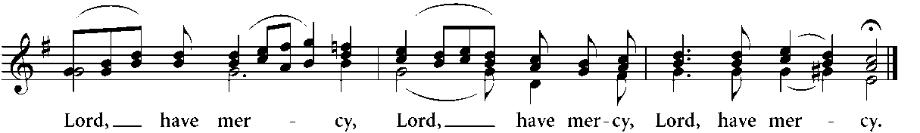

All:

Deacon: Wisdom! Stand aright! Let us listen to the holy Gospel.

Priest: Peace be with all.

All: And with your spirit.

Deacon: A reading from the holy Gospel according to name.

All: Glory be to You, O Lord, glory be to You.

Priest: Let us be attentive!

After the Gospel has been read, the priest says: Peace be with you, proclaimer of the Good News.

All: Glory be to You, O Lord, glory be to You.

Dismissal for the Passion Week

Lord, who hastens to His voluntary passion, Christ our true God, through the prayers of His immaculate Mother; of the holy, glorious and all-praiseworthy apostles; of the holy and righteous ancestors of God, Joachim and Anne; and all the saints, will have mercy and save us, for He is good and loves mankind.